Explanation of the two solutions
Both functions implement the mathematical definitions you saw in the lectures, exactly as written with the summation symbol ∑ \sum ∑.

1. compute_cost – What it is intended to do
The cost function measures how bad a particular pair of parameters (w,b) (w, b) (w,b) is:

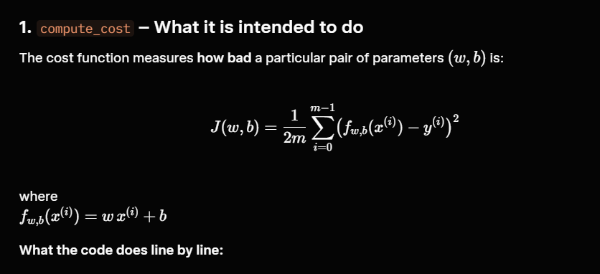
What the code does line by line:
Python
Copy
m = x.shape[0] # number of training examplestotal_cost = 0cost_sum = 0 # accumulator for the sumfor i in range(m): # go through every training example f_wb = w * x[i] + b # prediction for example i cost = (f_wb - y[i]) ** 2 # squared error for example i cost_sum = cost_sum + cost # add it to the total sumtotal_cost = (1 / (2 * m)) * cost_sum # average and divide by 2
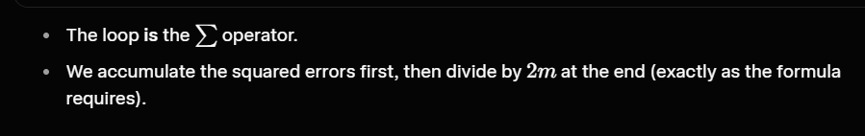
- The loop is the ∑\sum ∑ operator.
- We accumulate the squared errors first, then divide by 2m2m 2m at the end (exactly as the formula requires).

2. compute_gradient – What it is intended to do

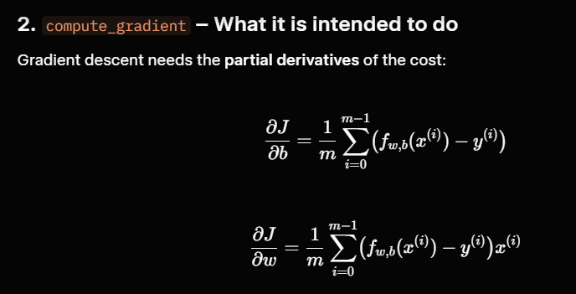
Gradient descent needs the partial derivatives of the cost:

What the code does:
Python
Copy
m = x.shape[0]dj_dw = 0dj_db = 0for i in range(m): f_wb = w * x[i] + b # same prediction as above dj_db_i = f_wb - y[i] # contribution of this example to ∂J/∂b dj_dw_i = (f_wb - y[i]) * x[i] # contribution of this example to ∂J/∂w dj_db += dj_db_i # accumulate dj_dw += dj_dw_idj_dw = dj_dw / m # averagedj_db = dj_db / m
Again, the for loop implements the summation. After the loop we divide by m m m to get the average gradient.

Why a for loop? (Important pedagogical reason)
- Faithfulness to the math The lectures write everything with ∑i=0m−1\sum_{i=0}^{m-1} ∑i=0m−1​. Writing a loop makes the code a direct translation of the formula. You can see every term.
- This is the first programming lab Andrew Ng’s course deliberately starts with explicit loops so that students:
  - understand what is being computed,
  - can debug easily,
  - do not hide the math behind vectorized NumPy operations too early.
- Later you will vectorize In the next weeks you will rewrite the same functions using matrix operations (no loops). The loop version is the foundation that makes the vectorized version understandable.

How these two functions are used together
In the gradient_descent function you already have:
Python
Copy
for i in range(num_iters): # 1. Compute the current gradients dj_dw, dj_db = compute_gradient(x, y, w, b) # 2. Update the parameters w = w - alpha * dj_dw b = b - alpha * dj_db # 3. (optional) compute cost to monitor progress cost = compute_cost(x, y, w, b)
So:
- compute_cost → tells you “how good / bad am I right now?”
- compute_gradient → tells you “in which direction and how strongly should I move ww w and bb b?”
That is the entire core of batch gradient descent for linear regression.

